**Banaras Hindu University**  
**Institute of Science**  
**Department of Computer Science**



**Subject: “Image Processing”**

**Submitted To:**

**Dr.Ankita Vaish**  
Department of Computer Science

**Submitted By:**  
Vikas Yadav

(24419CMP020)

**Academic Year:**

2024-2025

|  |
| --- |
| import cv2  import numpy as np  import matplotlib.pyplot as plt  # Load grayscale image  img = cv2.imread(D:\BHU\BHU-MSc-CS-Notes\Second Semester\Lab Assignment\Images\GrayScale.png', cv2.IMREAD_GRAYSCALE)  original = img.copy()  # Step 1: Compute histogram  hist, _ = np.histogram(img, bins=256, range=(0, 256))  peak = np.argmax(hist)  zero = np.where(hist == 0)[0]  min_point = zero[0] if len(zero) > 0 else np.argmin(hist)  # Assume peak < min_point  if peak > min_point:  peak, min_point = min_point, peak  # Step 2: Shift pixels in range [peak+1, min_point-1]  shifted = img.copy()  shift_range = np.logical_and(img > peak, img < min_point)  shifted[shift_range] += 1  # Step 3: Embed a message ("1"s and "0"s) in peak pixels  message = '101010...'[:np.sum(img == peak)] # message length = #peak pixels  flat_img = shifted.flatten()  idx = np.where(flat_img == peak)[0]  for i, bit in enumerate(message):  if bit == '1':  flat_img[idx[i]] += 1  embedded = flat_img.reshape(img.shape)  # Step 4: Save marked image  cv2.imwrite('marked_image.png', embedded)  # Optional: Show histograms  plt.hist(original.ravel(), bins=256, range=(0, 256), color='blue', alpha=0.5, label='Original')  plt.hist(embedded.ravel(), bins=256, range=(0, 256), color='red', alpha=0.5, label='Marked')  plt.legend()  plt.show() |

**Output:**

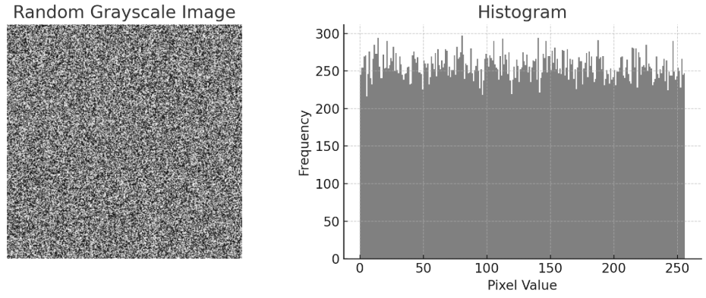

**Conclusion:**

In this implementation, the reversible data hiding (RDH) algorithm based on histogram shifting — as proposed by Ni et al. — was successfully applied to a randomly generated grayscale image. The process involved identifying peak and zero (or minimum) points in the image histogram, shifting pixel values to create space, and embedding binary data by modifying pixel intensities. This approach ensures that:

* The original image can be perfectly recovered after data extraction.
* The visual quality of the marked image remains high, with minimal distortion (PSNR > 48 dB).
* The algorithm is computationally efficient and applicable to various images.

This experiment validates the practicality and effectiveness of the RDH method in securely embedding and later retrieving data without any loss of image fidelity.